What is eBay and how does it work?
Article source: What is eBay? And How Does It Work? by TechBoomers.com

One of the major things that the Internet has made easier is the conducting of commercial transactions. This is true for both large-scale business deals as well as small-scale person-to-person trades.

In the latter case, take for example the website "AuctionWeb". It was created in 1995 by entrepreneur Pierre Omidyar to auction off miscellaneous objects that he owned, such as laser pointers. Two years later, Omidyar renamed the website after a short-form version of his technology consulting business, and it became what is now known as "eBay".

eBay has since grown into a multi-billion-dollar online marketplace, including classified advertisements (eBay Classifieds), reverse auctions (Half.com), and event ticket trading (StubHub).

So, what exactly is eBay?
eBay is one of the oldest and most successful e-commerce websites on the Internet, but it doesn't sell any items itself. Instead, it allows users to list items for sale, which other users can then bid on in auctions. Recently, Ebay has also added options to buy items at face value, or submit price offers for them.

How does eBay work? Top 4 features of eBay

1. Save money by bidding instead of buying
By bidding on items in an auction on eBay, you might be able to win those items for the second-highest bid, plus a little extra. If you learn how to participate in auctions well enough, you could end up winning items at prices that are less than at retail! We'll have some tips on how to do this in our How does Bidding on eBay Work?, How to Bid on eBay, and eBay Bidding Tips tutorials.
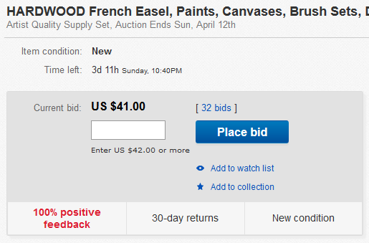

2. Name your price and haggle
For some items, you may be able to convince their owners to sell them to you for less than their current asking prices. Submit a "Best Offer" for an item, naming what price you are willing to pay for it. If the seller is desperate enough to make a sale, they may accept your offer, or make a counter-offer that you can accept. For more information on "best offers", see our eBay Best Offers tutorial.
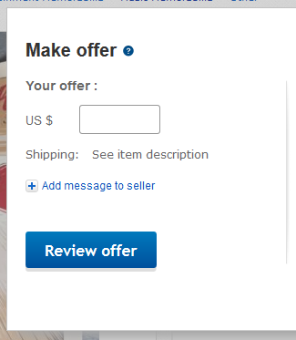

3. Fixed prices for when you're in a rush
If you don't feel like bidding for an item on eBay or trying to talk the seller into lowering the price, many items have the option to Buy It Now at a fixed price. No muss, no fuss... just pay for the item and have it delivered. Our How to Buy on eBay tutorial will cover how to shop this way.
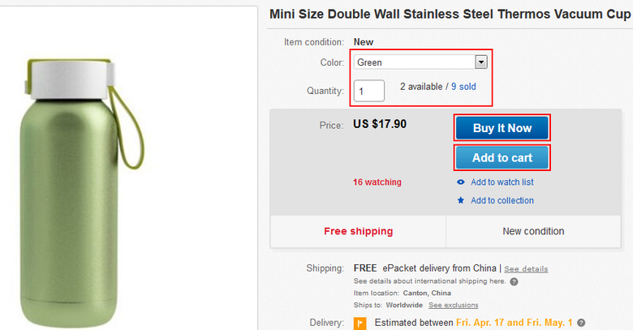

4. You can sell, too!
Got some stuff lying around the house that you don't want anymore? List it on eBay and see if it will sell. You can hawk it at a fixed price, accept offers from buyers if you just want to get rid of it at any price, or put it up for auction and see how much money you can get for it! We'll be making a whole series of tutorials later on how to sell on eBay, so stay tuned!

What can I buy or sell on eBay?

Why, almost anything! eBay is a relatively open market, so you can buy and sell many different categories of items, including:

- art, antiques, and collectibles
- home electronics (computers, cameras, TVs, sound systems, mobile phones)
- video games & consoles, music, videos, and even event tickets (via StubHub)!
- clothes, shoes, and jewellery
- sports and fitness equipment
- home decor and renovation tools
- toys (board games, action figures, dolls, stuffed animals)
- books, magazines, and posters
- business and industrial equipment
- cosmetics and other health and beauty products
- cars, boats, motorcycles, off-road vehicles, and vehicle parts (via eBay Motors)

There are certain items that can't be bought or sold on eBay -- or only bought and sold under certain special conditions -- such as alcohol, tobacco, weapons (such as firearms and knives), drugs or drug accessories, or other hazardous items such as fireworks. For more information, see this help page on Prohibited and Restricted Items on eBay.

Well, that's a quick run-down of what eBay is!

